Query all columns for a city in **CITY** with the ID 1661.

The **CITY** table is described as follows:  
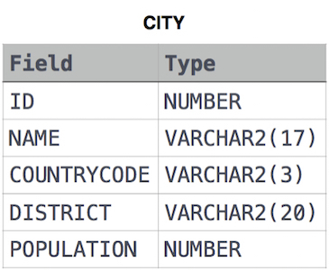

**Ans:**

Select * from CITY where ID=1661;